Thank you so much for your kind words. Your compliments are especially meaningful coming from such educated, cultured and real people like you. You both have my utmost respect because you have made such a difference in this world in a caring an d meaningful way, leaving this world a better place than before you arrived. I’m honored to know you Felicity and look forward to meeting you Jacques in October. Please contact me upon your arrival and Shall meet in November.

Best,

Alan Bell (author “Poisoned” Environmental Health expert

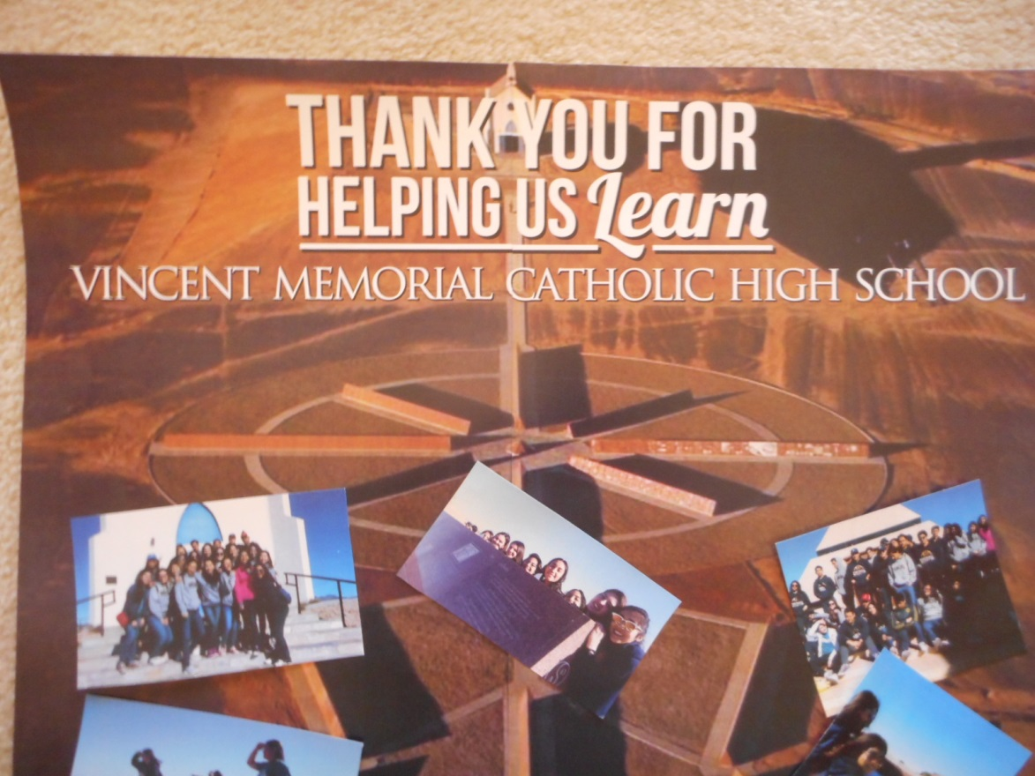

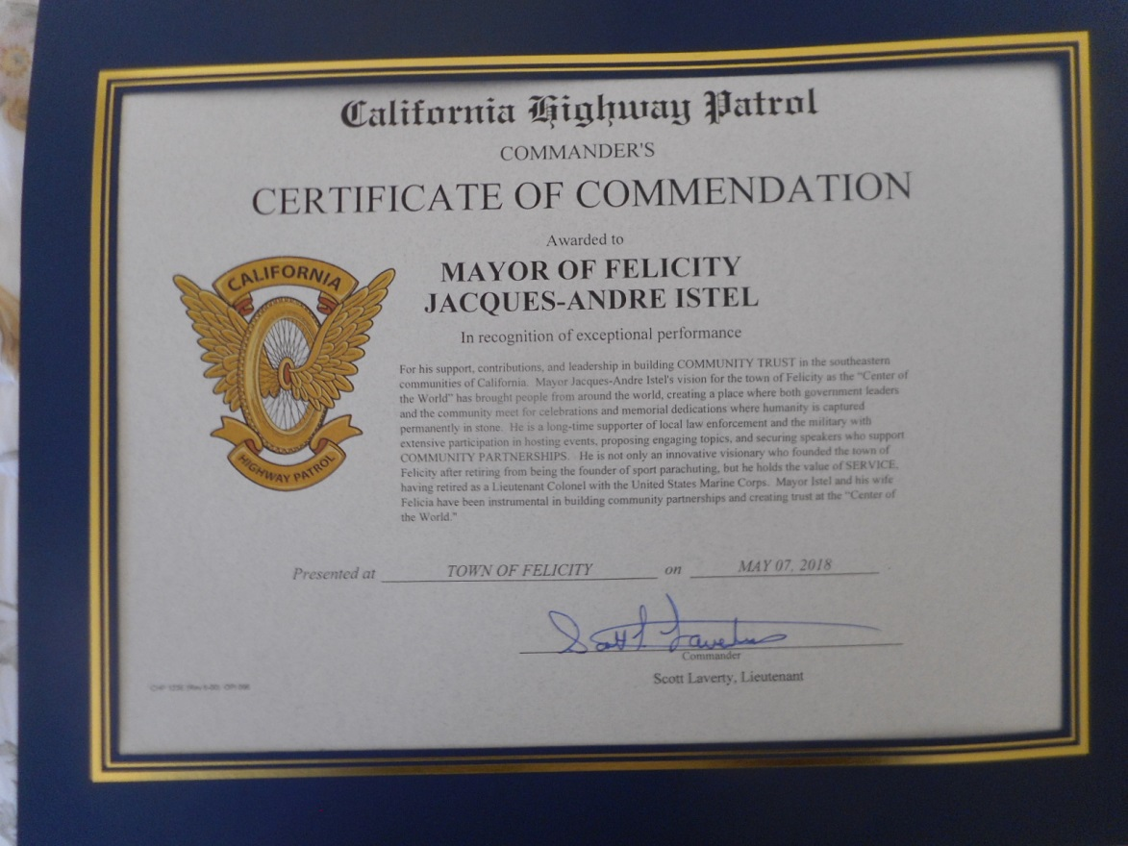

 From Tracey Moore 5 star review in Google 6 Sept 2018

This place is an unusual marvel. A lot of time, effort, and money went into these granite displays of the history of our world as we know it, and it truly feels like it's out in the middle of nowhere! There's so much to see, it's hard to comment on it all, but what impressed me the most was a history of the French Foreign Legion in granite, which is written in French and English. You have to see this place to believe it. Definitely worth visiting.